Assignment 1
Group Details:
Group No: 173
Sl. No. | BITS ID | Name | Contribution of Team Member (Qualitative) | Contribution of Team Member (Quantitative)
1. | 2025AA05957 | ABHISHEK | 100 | 100
2. | 2025AA05729 | ASHMIT BHANDARI | 100 | 100
3. | 2025AA05478 | RISHABH JAIN | 100 | 100
4. | 2025AB05319 | UDIT SHARMA | 100 | 100

Project Details
Objective 1: Requirements Formulation
- Select a domain and define an appropriate problem statement for an ML-based application of your choice.

1.1 Domain
Insurance

1.2 Project Title
Health Insurance Cross-Sell Prediction System

1.3 Problem Statement
An insurance company currently offers health insurance to its customers. The company wants to identify customers who are most likely to purchase vehicle insurance. Instead of contacting every customer, the marketing team wants to prioritize customers with the highest purchase probability using Machine Learning.

Business Problem
Current Challenges:
- Marketing campaigns target all customers.
- Low conversion rates.
- High customer acquisition cost.
- Inefficient resource utilization.

ML Solution
Develop an AI-powered recommendation system that predicts whether a customer will purchase vehicle insurance.

Stakeholders
Stakeholder | Goal
Marketing Team | Target interested customers
Sales Team | Increase policy sales
Customers | Receive relevant offers
Insurance Company | Improve revenue and reduce campaign costs

- Formulate the requirement specifications and establish measurable goals for the proposed ML-based application using GR4ML concepts.

2.1 Functional Requirements
FR1: System shall load customer information.
FR2: System shall preprocess the data.
FR3: System shall engineer additional features.
FR4: System shall predict purchase probability.
FR5: System shall display probability score.
FR6: System shall explain prediction using SHAP.
FR7: System shall allow batch prediction.
FR8: System shall save prediction history.

2.2 Non-Functional Requirements
NFR1: Prediction latency < 500 ms
NFR2: Availability > 99%
NFR3: Secure REST APIs
NFR4: Explainable predictions
NFR5: Scalable architecture
NFR6: Maintainability
NFR7: Reproducibility

2.3 Measurable Goals
Goal | Target
ROC-AUC | >0.88
Recall | >75%
Precision | >40%
Response Time | <500 ms
Uptime | 99%
Batch Prediction | 10000 customers

- Using GR4ML notations, develop the following views for the application:
3.1 Business View
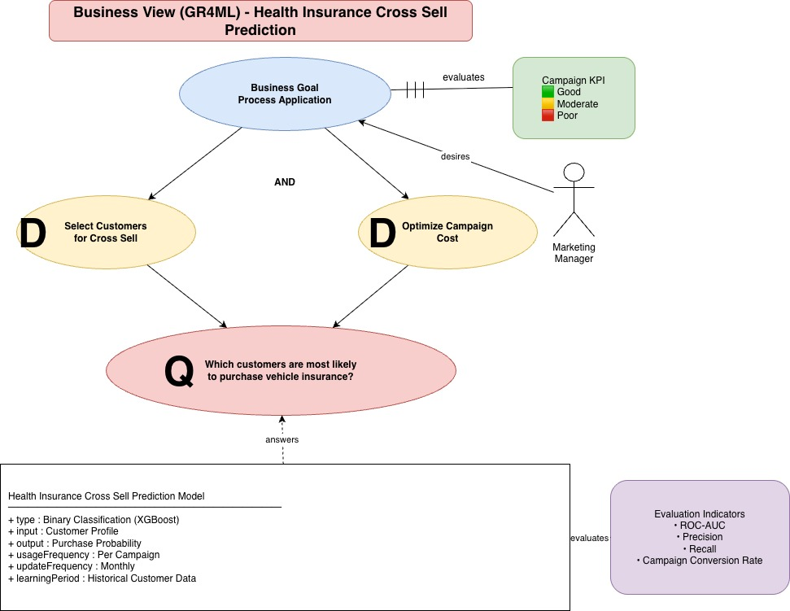

3.2 Analytics Design View
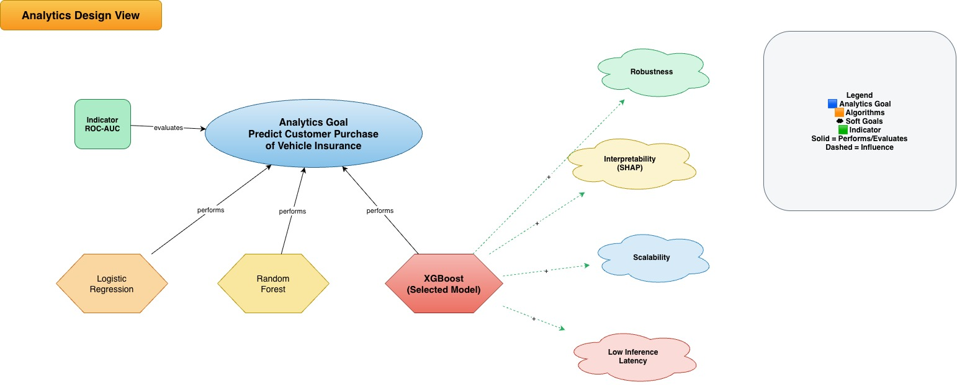
3.3 Data Preparation View
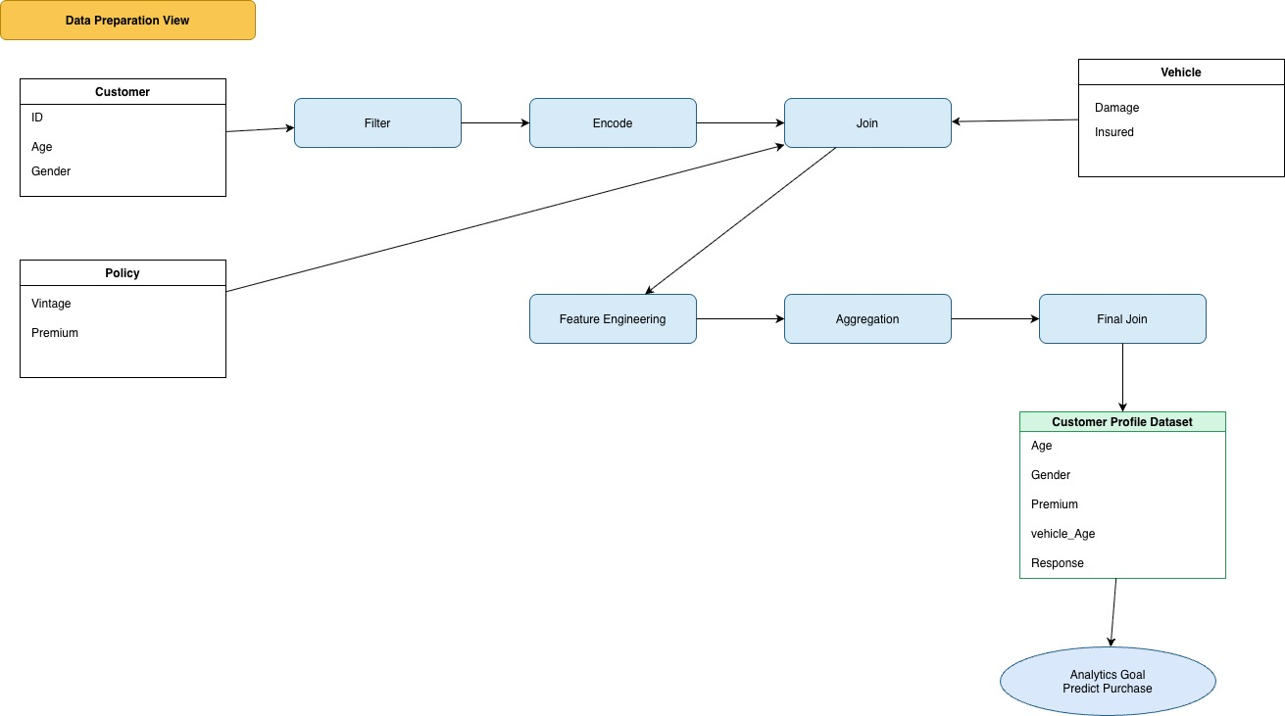
- Identify the top three quality requirements for the application and provide justification for their selection.

4.1 Accuracy
Reason: Wrong prediction results in contacting uninterested customers, increasing operational costs.
Target: ROC-AUC > 0.88

4.2 Explainability
Reason: Insurance companies must justify recommendations and support business decisions.
Technology: SHAP

3. Scalability
Reason: The model should support predictions for millions of customers without significant performance degradation.
Technology: FastAPI + Docker + Azure

Objective 2: System Architecture
- Draw a system architecture diagram for the selected application, clearly illustrating both ML and non-ML components. You may use any suitable tool of your choice to create the diagram.

5.1 ML Components
- Data Validation
- Feature Engineering
- XGBoost Model
- SHAP Explainability
- Prediction Service

5.2 Non-ML Components
- Streamlit UI
- FastAPI Backend
- REST APIs
- Logging
- Model Repository
- Docker
- GitHub Actions
- Azure Deployment
